Miracle Child Kelly
Tori Nestel - President & Chief Executive Officer of Children’s Miracle Network Hospitals
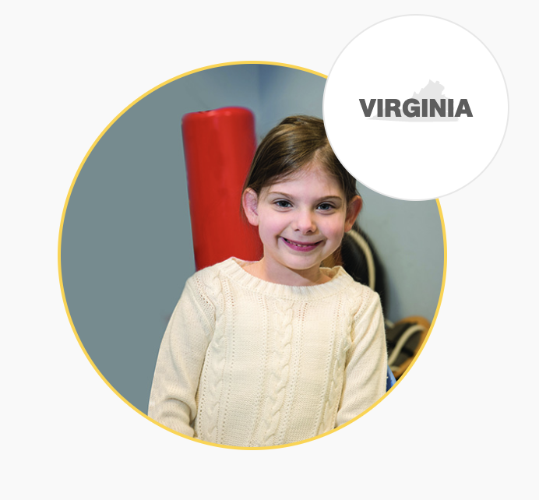
Kelly is a miracle child who is treated at the Children’s Miracle Network Hospital of Richmond. Before birth, doctors delivered the devastating news to her parents that she would be born with an extremely severe form of spina bifida called myelomeningocele, and hydrocephalus, a buildup of fluid in the brain. Doctors weren’t even sure that Kelly would be able to make it through the pregnancy. The CMNH care team developed a complex birth plan, and Kelly was born on July 8th. Due to her condition, she had surgery at 4-days-old, and again a week later.
Kelly spent her first month of life in the NICU, where her parents saw the wonderful staff help their baby grow and thrive. Kelly has had multiple surgeries and physical therapy since infancy, helping her learn to move independently. Thanks to therapy, she now relies on her wheelchair, crutches, and a walker; tools that ensure she can keep up with her peers. Her physical therapist says, "Kelly doesn't see obstacles." She bravely lives her life and conquers every challenge she faces.
Miracle children and their families, like Kelly and her parents, rely on Children’s Miracle Network hospitals for care, treatment, and anything else that can improve the quality of their lives. The donations and funds raised by individuals and groups help offer survival and healing to these people who are in need. Interaction with these children offers hope and joy for them.
It is more important than ever to recognize the medical challenges that families face in the United States. There is no way of knowing when or if these challenges can become our own. Kelly has been able to not let her physical limitations define her, because of the quality care that she has received. She is able to play, laugh, and make happy memories, like every child deserves to. We can all play an important role in offering compassion to children like Kelly.
Every person should consider the difference that they can personally make in the lives of kids like Kelly. While CMNH hospitals used to have in-person visits, children can still be engaged with via Zoom calls and experience happiness when they receive gifts or care packages. It is so wonderful to see the impact that community outreach and involvement has on these children. Donations and contributions are always welcome, even a teddy bear could make a child’s day, week, or year. Every person matters, and every person can make a positive difference. Consider offering your care to Miracle children today, by getting personally involved.
---------------------------------------------------------------------------------------------------------------------
The mission of Children’s Miracle Network Hospitals is to improve the quality of life of miracle children, as well as to increase funds and awareness for your local children's hospital and other Children's Miracle Network Hospitals.

