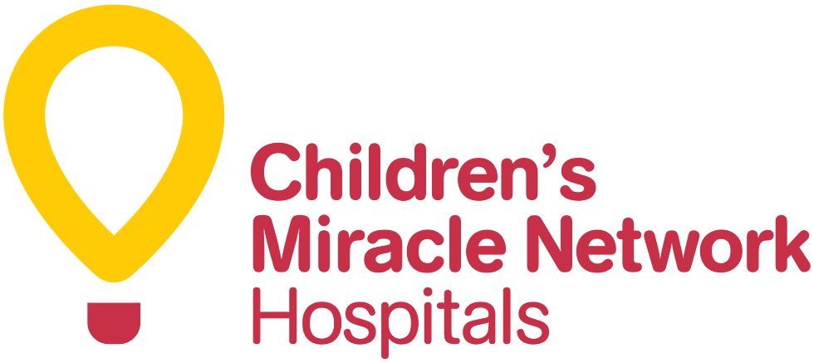

FOR IMMEDIATE RELEASE

Contact: Reese Orwig (703) 635 6692, [orwigrm@vcu.edu](mailto:orwigrm@vcu.edu)

RAMTHON AT VCU MARCH 27 2021

RICHMOND, Va. Mar. 21, 2021 – Virginia Commonwealth University will be holding its 6th annual dance marathon to raise proceeds for Children’s Miracle Network Hospitals on March 27th. This event put on by VCU community members is called Ramthon and every penny raised goes towards CMNH. Even with the program being virtual last year, Ramthon raised $3,000 for Children’s Miracle Network Hospitals.

Due to COVID-19, the dance marathon will have to be virtual once again. Participants in the event will log on from noon to six in order to raise money for CMNH. Patients at hospitals and their families will be able to tune in and observe the fundraising campaign.

“We appreciate the students who participate and make a difference for these children and their families,” said CEO Teri Nestel, “it goes beyond the fundraising.”

It is important and valuable that this event continues on despite COVID-19. Everyone is encouraged to participate somehow and make a positive difference. These dance marathons are beneficial to individuals and the whole organization, and they should be celebrated, recognized and reported as such. This is a great occasion for media coverage. Get your cameras, sign up, and get involved today for this one-of-a-kind opportunity to dance and help save children!

####

Children’s Miracle Network Hospitals is a non-profit organization that works to improve the quality of life for very sick or injured children. CMNH is supported through donations from the public, in order to provide treatment and care for children. <https://chfrichmond.childrensmiraclenetworkhospitals.org/>