3 screenshots of news pitches to journalists regarding VCU’s Ramthon event

Links reincluded to photos for access

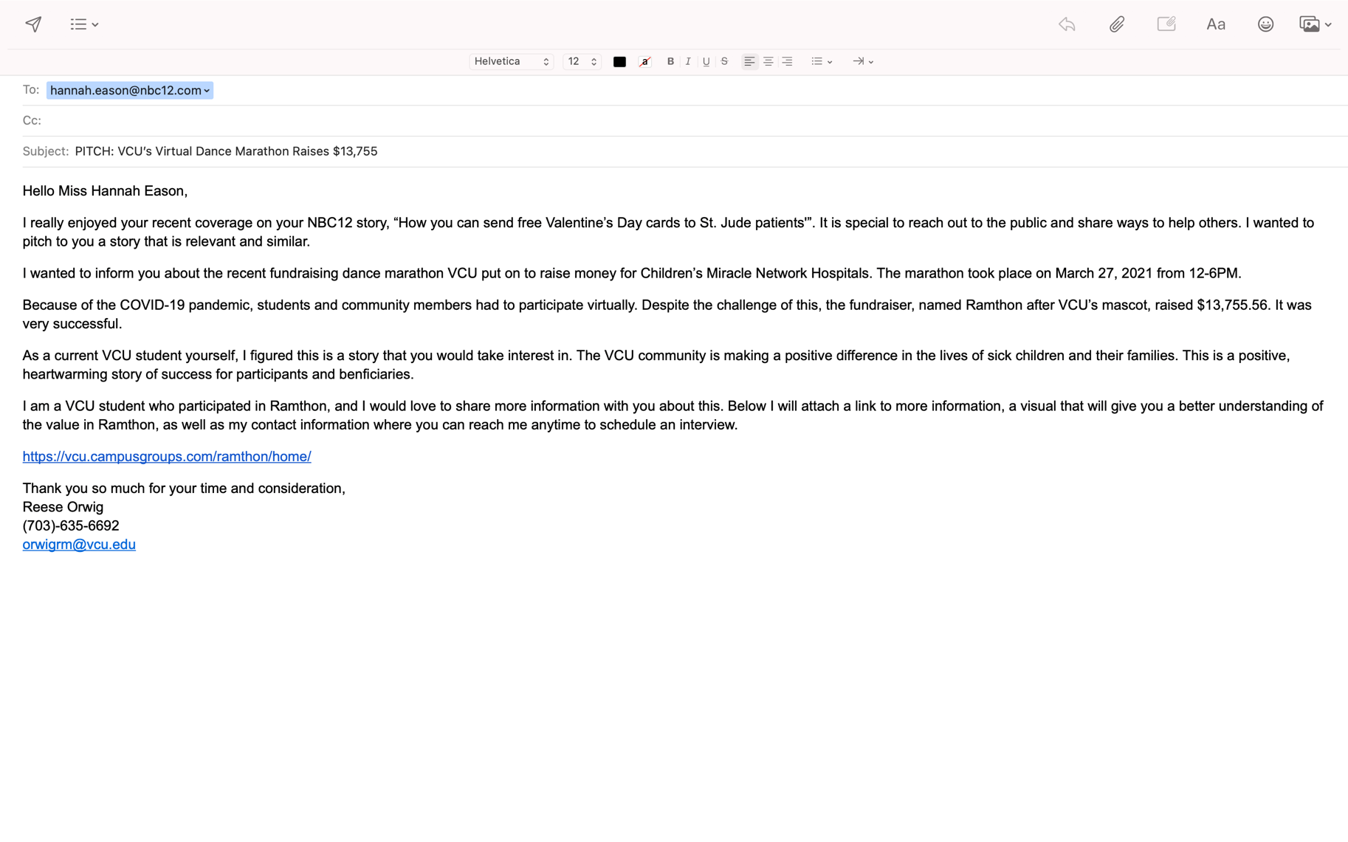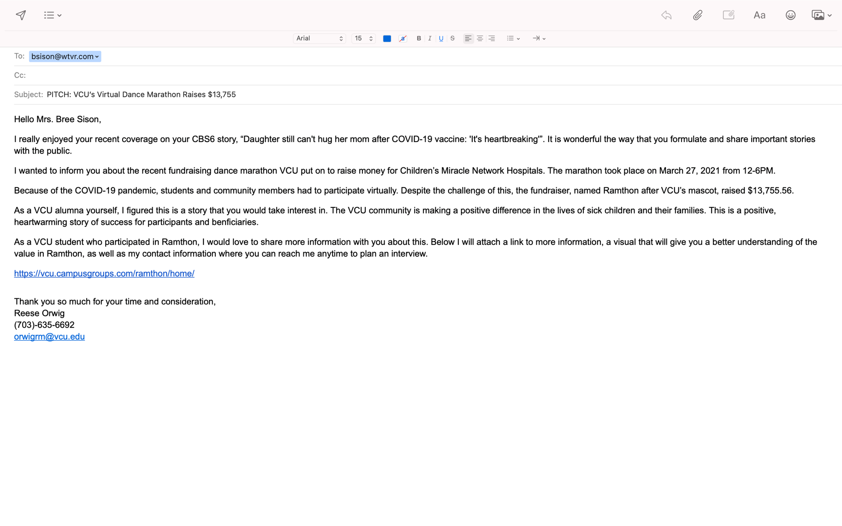

[orwigrm@vcu.edu](mailto:orwigrm@vcu.edu)

<https://vcu.campusgroups.com/ramthon/home/>

<https://vcu.campusgroups.com/ramthon/home/>

[orwigrm@vcu.edu](mailto:orwigrm@vcu.edu)

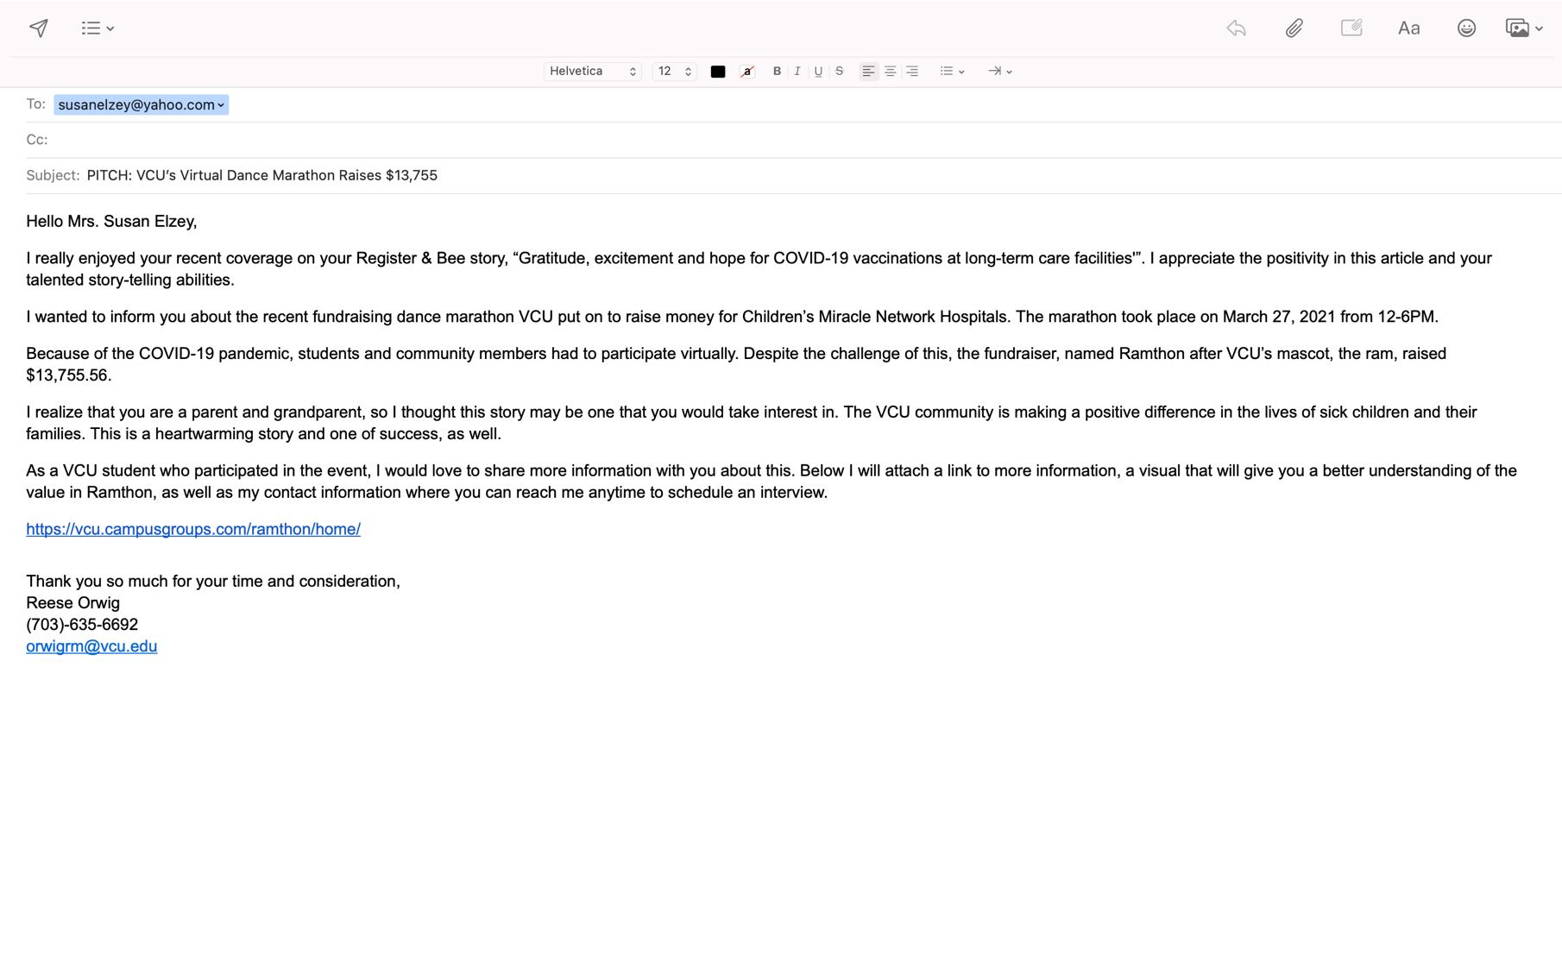

[orwigrm@vcu.edu](mailto:orwigrm@vcu.edu)

<https://vcu.campusgroups.com/ramthon/home/>